CHEMICAL ENGINEERINGTRANSACTIONS  VOL. 73, 2019 | A publication of
The Italian Association
of Chemical Engineering
Online at www.aidic.it/cet
Guest Editors:Andrea D’Anna, Paolo Ciambelli, Carmelo Sunseri
Copyright © 2019, AIDIC ServiziS.r.l.
ISBN978-88-95608-70-9;ISSN 2283-9216

A Study on the Relationship between the Boundary Flux Parameters and Membrane Process Requirements
Marco Stoller^{a*}, Javier Miguel Ochando Pulido^{b}
ª Sapienza University of Rome, Dept. Of Chemical Materials Environmental Engineering Via Eudossiana 18, 00184 Rome, Italy
^{b} University of Granada, Dept. of Chemical Engineering, Avenida de la Fuente Nueva S/N, 18071 Granada, Spain
marco.stoller@uniroma1.it
The boundary flux concept permits to describe the fouling behaviour of membrane systems as a function of the operating time. The method relies on a set of equations that is possible to integrate in time, thus permitting to evaluate the separation process outcome and performances. This study focuses on the relationship between the membrane area requirements and specific parameters of the boundary flux concept on different membrane systems characterized by different waste feed streams and operating conditions. The target of the analysis was to identify which parameters of the boundary flux equations are the most influent one on the membrane area requirements. The knowledge of the relevant parameters can strongly assist membrane process designers to minimize the capex of the developed plants. The study was performed on many different systems, available in literature, and at different operating conditions. In order to avoid the triggering of irreversible fouling, the operation must be performed in sub-boundary operating conditions, and as a consequence, the condition of the permeate flux J_{p} equal to the boundary flux J_{b} must be met at the end of operation. Summarizing briefly the findings, it was possible to observe that the membrane area requirements are minimized for higher pure water membrane permeability values (w) for recoveries up to 75% Y_{max}, but then, in the range up to 90% Y_{max}, to achieve the same target, it appears to be more important to have higher J_{b} values. In other words, in those systems characterized by VRF (volume recovery factor) less than 4, high membrane permeabilities appears advantageous for the choice, even in presence of some extent of fouling. This appears not to be the case for those systems targeting higher VRF values: in this case, high J_{b} values must be achieved. Since the value of J_{b} depends on many parameters, such as T, Re and other physical-chemical characteristics, the minimization of the membrane area requirements requires the proper design of the membrane process, pre-treatment steps and operating conditions choice.
  - Introduction
Membrane fouling is one of the most important drawback of membrane technologies (Stoller et al., 2013). Although research in developing new membrane materials as well as in fouling inhibition methods development was performed in the last decades, membrane fouling still leads to process failures (Bavasso et al., 2016). As a consequence, an improved attention to fouling issues should be given in the next future. Indeed, more efficient design, implementation and operation techniques should be developed to target an improved reduction of this phenomenon (Di Palma et al., 2018), in order to increase the life time of membranes and as a consequence to reach technical and economic feasibility of the treatment (Ochando-Pulido and Stoller, 2015). The fouling phenomena triggers over the surface of the membrane the formation of a gel like cake layer, that grows as a function of time driven by polarization and inhibits the passage of the permeate trough the membrane (Mi and Elimelech, 2010). As a function of the nature and molecular organization of the cake layer, fouling can be classified by three different types: reversible, semi-reversible and irreversible, respectively (Kimura et al., 2004).
The outcome of fouling and the relative growth rate of the cake layer depends on different parameters, such as: selectivity, dimension distribution of the membrane pores, feed stream characteristics and suspended solids particles size distribution, chemical and physical properties of the solute and finally the applied operating pressure. In any case fouling cannot be avoided completely but can be inhibited by taking some precautions, such as pre-treatment processes on the feed stream, i.e. photocatalysis (Stoller et al., 2017a), prefiltration (Stoller et al., 2016), adsorption (Vilardi et al., 2018a), chemical precipitation (Vilardi et al., 2018b), advanced oxidation processes (Vilardi et al., 2018c), biological processes (Bavasso et al., 2017) frequently cleaning the membrane surface by water or specific chemicals or avoiding to operate the system at too high pressure values (Stoller et al., 2017b). Once the system is defined, the last step of membrane process design is to determine the proper membrane area requirements to operate in fouling inhibited conditions. Various wastewater pre-treatments have been developed (Vilardi et al., 2017a) through the use of nanoparticles (Vilardi, 2019), such as metallic iron-based (Vilardi et al., 2017b), magnetite-based (Vilardi et al., 2018d), silica-based (Chinh et al., 2019) and titania-based ones (Chinh et al., 2018). Other efficient pre-treatments require the use of Fenton-like processes (Vilardi et al., 2019a), also employing nanoparticles (Vilardi et al. 2018e) other advanced oxidation processes (Vilardi et al., 2018f) and analogous intensified processes (Vilardi et al., 2019b).
At industrial level, interest focuses on a fixed capacity of the process, therefore to operate the plant at constant permeate flow rates in order to reach both targets from an economic and a productive point of view, respectively (Stoller et al., 2018). This requires to adopt specific control system designs that relies on a proper knowledge of the fouling behaviour and development as a function of time during operation. One possibility to evaluate the evolution of fouling is to adopt the boundary flux concept (Stoller and Serrão Mendes, 2017). Briefly explained, the boundary flux is equal to the maximum allowable permeate flux that can be obtained by a specific system without the occurrence of irreversible fouling formation, as a function of time. Therefore, the knowledge of the boundary flux value as well as other parameters, such as the sub-boundary fouling rate index α, permits to properly design and control the membrane process for a long period of time.
In this paper, the boundary flux concept will be presented and will be checked for its usefulness in determining the membrane area requirements A as a function of the recovery Y for different feed streams by using MF (microfiltration), UF (ultrafiltration) and NF (nanofiltration), respectively. The analysis shows that only at higher values of Y the ongoing fouling phenomena should be taken into account for optimized membrane process design purposes. On contrary, at lower Y values, the most relevant design parameter appeared to be the membrane performances in terms of high membrane permeability values.
  - Methods
The boundary flux concept permits to describe the fouling behaviour of membrane systems as a function of the operating time. The method relies on a set of equations that is possible to integrate in time, thus permitting to evaluate the separation process outcome and performances.
In order to perform this study, data was taken from literature and a simulation code was used to calculate the separation outcome and performances of all of the selected systems. The details of the relevant nomenclature of the used variables within this paper are reported elsewhere (Stoller and Ochando-Pulido, 2014).

Below, the used model equations set are described:

$-\frac{dm}{dt}= α; when Jp\left(t\right)≤Jb$ (1)

$-\frac{dm}{dt}= α+β\left(Jp\left(t\right)-Jb\right); when Jp\left(t\right)>Jb$ (2)

Where:
J_{p}(t) is the the permeate flux in function of the time [Lh⁻¹m⁻²];
J_{b} is the value of boundary flux [Lh⁻¹m⁻²];
m represents the permeability of the membrane area [Lh⁻²m⁻²bar⁻¹];
α represents the constant permeability reduction rate by the system [Lh⁻²m⁻²bar⁻¹], called the sub-boundary fouling rate and valid for all flux values;
β represents the fouling behaviour in the exponential fouling regime of the system [h⁻¹m⁻²], called super-boundary. This term is not constant but change in function of the transmembrane pressure (TMP).

A proper membrane process design should always target to sub-boundary operating conditions since irreversible fouling is avoided or at least strongly inhibited, thus maximizing the longevity of the membrane modules. This latter aspect is of particular importance in those applications of low added value products such as purified water from waste water streams, in order to reach economic feasibility of the treatment process.
The analyses were grouped as a function of the membrane pore size, considering the common way to define different membrane classes (MF, UF, NF). Within each class, the simulation code was used on different feed streams found in literature. In order to run the simulation, some input parameters are required, concerning feed stream characteristics (KP(0)), productivity (ρ1, m1, w), selectivity (σ, γ) and membrane fouling (J_{b}, TMP_{b}, α). Moreover, some input parameters were fixed for all runs, that is the initial feed stream volume and operating time, equal to 1000 l and 60 min, respectively.
The study was performed to determine the best value for A as a function of the recovery Y, calculated as:

$Y= \frac{V_{p}}{V_{f}}=1- \frac{1}{VRF}$ (5)

where V_{p} is the permeate volume, V_{f} the feed stream volume and VRF the volume recovery factor. In a first step, an infinite membrane area was fixed in order to determine the maximum possible recovery value Y_{max} for each different feed stream. Subsequently, the required membrane areas to reach pre-determined separation targets, in detail 50%, 75% and 90% of Y_{max}, respectively, were evaluated by adopting a Newtonian trial&error procedure. Finally, the obtained results in terms of membrane area requirements were analysed on those input parameters resulting the most influent one: the pure water permeability w and the boundary flux value J_{b}.
  - Results and Discussion
The obtained results in terms of membrane area requirement as a function of Y are reported in Figures 1 to 3, for MF, UF and NF, respectively. The given reference number of the plotted lines are the respective reference number of the tables reported in the boundary flux handbook (Stoller and Ochando-Pulido, 2014).It is possible to observe that the all the plots are similar in shape, characterized by a first part ranging from y50% to Y75% having higher angular coefficient when compared to the second one, from Y75% to Y90%. As a consequence, the subsequent analysis to check for some influence of w and/or Jb will be divided in two parts, regarding the different relative Y ranges. Concerning the first part, as ease of an example selected plots from UF and NF were reported in Figure2 and the relevant data in Table 1.
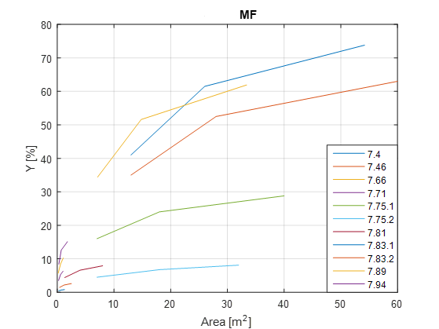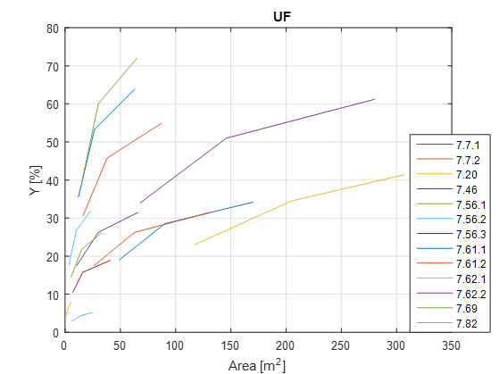
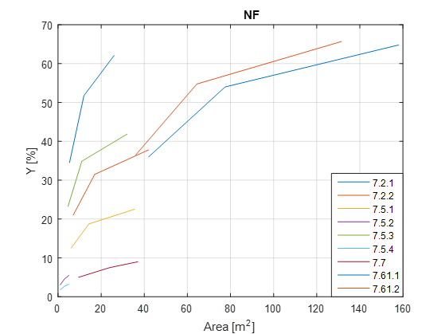
Figure 1: Membrane area requirement vs Y for different feed streams and MF, UF and NF
Table 1: Relevant data of the selected plots in Figure 2

UF |  |  |  | NF
Plot ID | ΔA/ΔY | w  [L/hm²bar] | J_{b}  [L/hm²] | Plot ID | ΔA/ΔY | w  [L/hm²bar] | J_{b}  [L/hm²]
7.46 | 0.78 | 72.0 | 25.0 | 7.2.1 | 0.27 | 15.3 | 84.0
7.61.1 | 1.64 | 5.2 | 8.2 | 7.2.2 | 0.40 | 14.3 | 45.0
7.61.2 | 1.48 | 5.2 | 10.0 | 7.5.1 | 0.33 | 9.8 | 35.6
7.82 | 0.26 | 234.8 | 84.6 | 7.61.1 | 1.42 | 2.5 | 11.8
 |  |  |  | 7.61.2 | 1.14 | 2.5 | 14.3

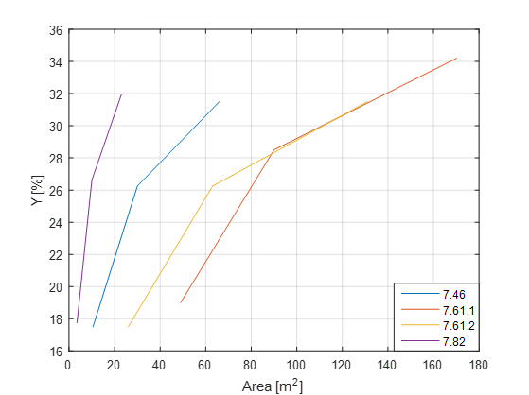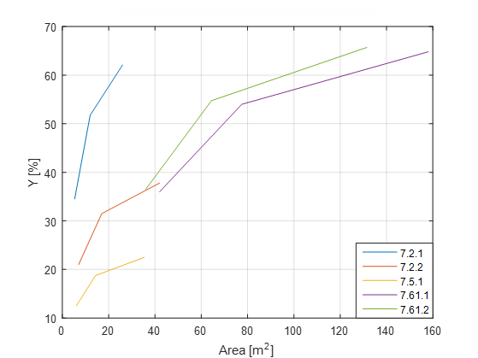
Figure 2: Selected plots from Figure1, UF (left) and NF (right), respectively

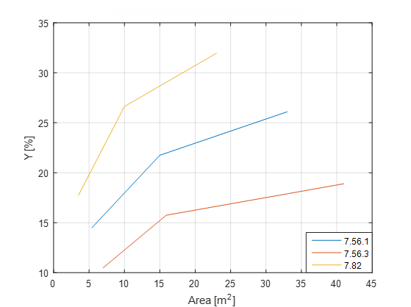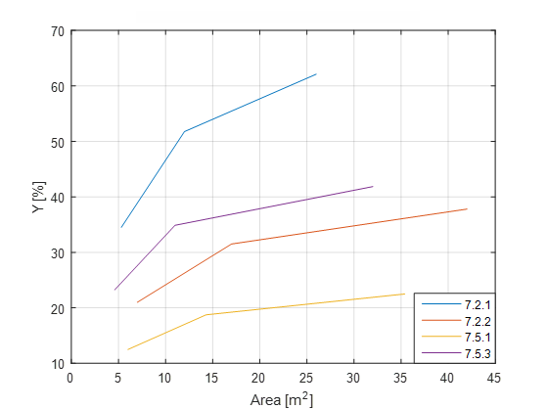

Figure 3: Selected plots from Figure1, UF (left) and NF (right), respectively
Table 2: Relevant data of the selected plots in Figure3

UF |  |  |  | NF
Plot ID | ΔA/ΔY | w  [L/hm²bar] | J_{b}  [L/hm²] | Plot ID | ΔA/ΔY | w  [L/hm²bar] | J_{b}  [L/hm²]
7.56.1 | 1.20 | 65.0 | 44.6 | 7.2.1 | 0.93 | 15.3 | 84.0
7.56.2 | 0.73 | 16.0 | 8.3 | 7.2.2 | 1.67 | 14.3 | 45.0
7.82 | 0.87 | 234.8 | 84.6 | 7.5.1 | 1.41 | 9.8 | 35.6
 |  |  |  | 7.5.3 | 1.40 | 14.3 | 81.3
From Table 1 it is possible to observe that for both membrane classes there is a relationship between ΔA/ΔY and w, whereas none can be observed towards J_{b}. The same property was confirmed for MF, too.
Concerning the second part, as ease of an example selected plots from UF and NF were reported in Figure3 and the relevant data in Table 2.
From Table 2 it is possible to observe that for both membrane classes there is a relationship between ΔA/ΔY and J_{b}, whereas none can be observed towards w. The same property was confirmed for MF, too.

The obtained results show that no particular attention must be given to fouling issues in those systems that are not strongly pushed in terms of recovery. For instance, for systems characterized by a VRF below 4, fouling issues can be neglected during process design. This is not the case for all other systems where VRF>4. In this case, the minimization of the membrane area requirements requires a careful evaluation and maximization of the relevant J_{b} value. Since the boundary flux value depends on many parameters, it appears to be profitable to achieve proper choice of operating conditions and pre-treatment steps to maximize J_{b}.
  - Conclusions
This study wanted to exploit strong relationships existing between membrane area requirements and specific parameters in presence of membrane fouling, in order to aid optimized membrane process design.
The obtained results show that no particular attention must be given to fouling issues in those systems that are not strongly pushed in terms of recovery. For instance, for systems characterized by a VRF below 4, fouling issues can be neglected during process design. This is not the case for all other systems where VRF>4. In this case, the minimization of the membrane area requirements requires a careful evaluation and maximization of the relevant J_{b} value. Since the boundary flux value depends on many parameters, it appears to be profitable to achieve proper choice of operating conditions and pre-treatment steps to maximize J_{b}.
References
Bavasso I., Vilardi G., Stoller M., Chianese A., Di Palma L., 2016, Perspectives in Nanotechnology Based Innovative Applications for The Environment, Chemical Engineering Transactions, 47, 55–60.
Bavasso I., Montanaro D., Petrucci E., Di Palma L. 2017, Shortcut biological nitrogen removal (sbnr) in microbial fuel cells (mfcs), Chemical Engineering Transactions, 57, 727-732.
Di Palma L., Bavasso I., Sarasini F., Tirillò J., Puglia D., Dominici F., Torre L., 2018, Effect of nano‐magnetite particle content on mechanical, thermal and magnetic properties of polypropylene composites. Polymer Composites, 39(S3), E1742-E1750.
Mi B., Elimelech M., 2010, Organic fouling of forward osmosis membranes, fouling reversibility and cleaning without chemical reagents, Journal of membrane science, 348(1-2), 337-345.
Kimura K., Hane Y., Watanabe Y., Amy G., Ohkuma N., 2004, Irreversible membrane fouling during ultrafiltration of surface water, Water research, 38(14-15), 3431-3441.
Ochando-Pulido J. M., Stoller M., 2015, Kinetics and boundary flux optimization of integrated photocatalysis and ultrafiltration process for two-phase vegetation and olive washing wastewaters treatment, Chemical Engineering Journal, 279, 387-395.
Stoller M., Ochando-Pulido, J. M., Chianese A., 2013, Comparison of critical and threshold fluxes on ultrafiltration and nanofiltration by treating 2-phase or 3-phase olive mill wastewater, 32, 397-402.
Stoller M., Ochando-Pulido J.M., 2014, The Boundary Flux Handbook, A Comprehensive Database of Critical and Threshold Flux Values for Membrane Practitioners, The Boundary Flux Handbook, A Comprehensive Database of Critical and Threshold Flux Values for Membrane Practitioners, 1-152.
Stoller M., Azizova G., Mammadova A., Vilardi G., Di Palma L., Chianese A., 2016, Treatment of Olive Oil Processing Wastewater by Ultrafiltration, Nanofiltration, Reverse Osmosis and Biofiltration, Chemical Engineering Transactions, 47, 409–414.
Stoller M., Serrão Mendes R., 2017, Advanced control system for membrane processes based on the boundary flux model, Separation and Purification Technology, 175, 527-535.
Stoller M., Ochando-Pulido J.M., Vilardi G., Vuppala S., Bravi M., Verdone N., Di Palma L., 2017b, Technical and economic impact of photocatalysis as a pretreatment process step in olive mill wastewater treatment by membranes, Chemical Engineering Transactions, 57, 1171-1176.
Stoller M., Vilardi G., Di Palma L., Chianese A., Morganti P., 2017a, Process intensification techniques for the production of nanoparticles for the cosmetic and pharmaceutical industry, Journal of Applied Cosmetology, 35 (1-2), 53-59.
Stoller M., Sacco O., Vilardi G., Pulido J.M.O., Di Palma L., Technical–economic evaluation of chromium recovery from tannery wastewater streams by means of membrane processes, 2018, Desalination and Water Treatment, 127, pp. 57-63.
Vilardi G., Di Palma L., Verdone N., 2017a, Competitive Reaction Modelling in Aqueous Systems, the Case of Contemporary Reduction of Dichromates and Nitrates by nZVI, Chemical Engineering Transactions, 60, 175–180.
Vilardi G., Stoller M., Verdone N., Di Palma L., 2017b, Production of nano Zero Valent Iron particles by means of a spinning disk reactor, Chemical Engineering Transactions, 57, 751–756.
Vilardi G., Di Palma L., Verdone N., 2018a, Heavy metals adsorption by banana peels micro-powder, Equilibrium modeling by non-linear models, Chinese Journal of Chemical Engineering, 26, 455-464.
Vilardi G., Mpouras T., Dermatas D., Verdone N., Polydera A., Di Palma L., 2018b, Nanomaterials application for heavy metals recovery from polluted water, the combination of nano zero-valent iron and carbon nanotubes, Competitive adsorption non-linear modeling, Chemosphere, 201, 716-729.
Vilardi G., Di Palma L., Verdone N., 2018c, On the critical use of zero valent iron nanoparticles and Fenton processes for the treatment of tannery wastewater, Journal of Water Process Engineering, 22C, 109–122.
Vilardi G., Ochando Pulido J.M., Verdone N., Stoller M., Di Palma L., 2018d, On the removal of Hexavalent Chromium by olive stones coated by iron-based nanoparticles: equilibrium study and Chromium recovery, Journal of Cleaner Production, 190, 200-210.
Vilardi G., Rodriguez-Rodriguez J., Ochando-Pulido J.M., Verdone N., Martinez-Ferez A., Di Palma L., 2018e, Large Laboratory-Plant application of a Tannery wastewater treatment by Fenton oxidation: Fe(II) and nZVI catalyst comparison and kinetic modelling, Process Safety and Environmental Protection, 117, 629-638.
Vilardi G., Ochando Pulido J.M., Stoller M., Verdone N., Di Palma L., 2018f, Fenton oxidation and chromium recovery from tannery wastewater by means of iron-based coated biomass as heterogeneous catalyst in fixed-bed columns, Chemical Engineering Journal, 351, 1-11.
Vilardi G., 2019, Mathematical modelling of simultaneous nitrate and dissolved oxygen reduction by Cu-nZVI using a bi-component shrinking core model, Powder Technology, 343, 613-618.
Vilardi G., Di Palma L., Verdone N., 2019a, A physical-based interpretation of mechanism and kinetics of Cr(VI) reduction in aqueous solution by zero-valent iron nanoparticles, Chemosphere, 220, 590-599.
Vilardi G., Rodriguez-Rodriguez J., Ochando Pulido J.M., Di Palma L., Verdone N., 2019b, Fixed-bed reactor scale-up and modelling for Cr(VI) removal using nano iron-based coated biomass as packing material, Chemical Engineering Journal, 361, 990-998.

